Nama : Bagus Tri Atmojo
JDT : 17
Tanggal : 18 Mei 2026

Tugas:
Membuat ERD dan file SQL untuk create dan insertnya
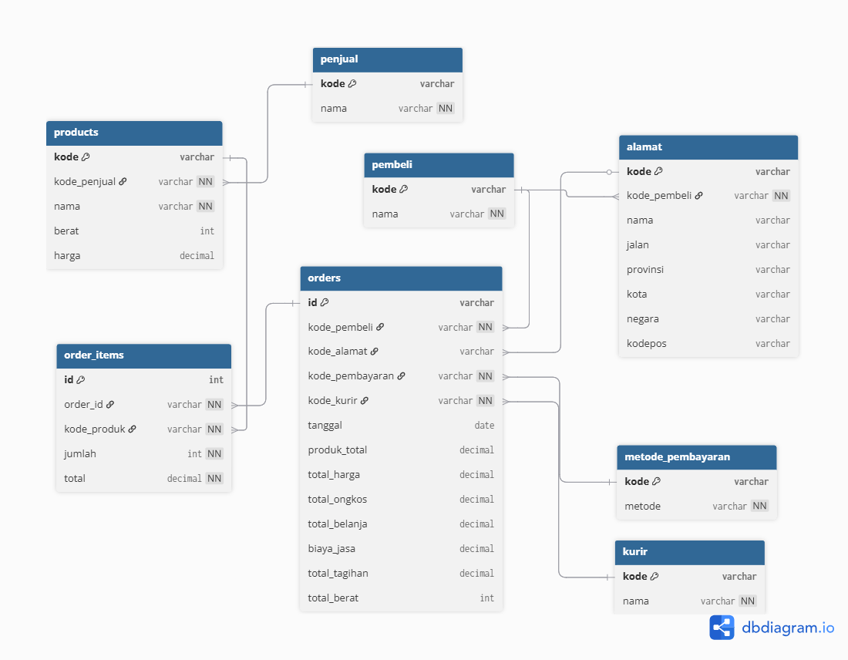

Code sql:
-- CREATE
CREATE TABLE penjual(
kode VARCHAR(10) PRIMARY KEY,
name VARCHAR(100) NOT NULL
);
CREATE TABLE metode_pembayaran (
kode VARCHAR(10) PRIMARY KEY,
metode VARCHAR(100) NOT NULL
);
CREATE TABLE kurir (
kode VARCHAR(10) PRIMARY KEY,
nama VARCHAR(100) NOT NULL
);
CREATE TABLE pembeli (
kode VARCHAR(10) PRIMARY KEY,
nama VARCHAR(100) NOT NULL
);
CREATE TABLE alamat (
kode VARCHAR(10) PRIMARY KEY,
kode_pembeli VARCHAR(10) NOT NULL REFERENCES pembeli(kode) ON DELETE CASCADE,
nama VARCHAR(100) NOT NULL,
jalan TEXT NOT NULL,
provinsi VARCHAR(100) NOT NULL,
kota VARCHAR(100) NOT NULL,
negara VARCHAR(100) NOT NULL DEFAULT 'ID',
kodepos VARCHAR(10) NOT NULL
);
CREATE TABLE products (
kode VARCHAR(10) PRIMARY KEY,
kode_penjual VARCHAR(10) NOT NULL REFERENCES penjual(kode) ON DELETE RESTRICT,
nama VARCHAR(255) NOT NULL,
berat INTEGER CHECK (berat > 0), -- dalam gram
harga NUMERIC(15,2) NOT NULL CHECK (harga >= 0)
);
CREATE TABLE orders (
id VARCHAR(20) PRIMARY KEY,
kode_pembeli VARCHAR(10) NOT NULL REFERENCES pembeli(kode) ON DELETE RESTRICT,
kode_alamat VARCHAR(10) REFERENCES alamat(kode) ON DELETE SET NULL,
kode_pembayaran VARCHAR(10) NOT NULL REFERENCES metode_pembayaran(kode) ON DELETE RESTRICT,
kode_kurir VARCHAR(10) NOT NULL REFERENCES kurir(kode) ON DELETE RESTRICT,
tanggal TIMESTAMPTZ NOT NULL DEFAULT NOW(),
produk_total NUMERIC(15,2) NOT NULL DEFAULT 0 CHECK ( produk_total > 0 ),
total_harga NUMERIC(15,2) NOT NULL DEFAULT 0 CHECK ( total_harga> 0 ),
total_ongkos NUMERIC(15,2) NOT NULL DEFAULT 0 CHECK ( total_ongkos > 0 ),
total_belanja NUMERIC(15,2) NOT NULL DEFAULT 0 CHECK ( total_belanja > 0 ),
biaya_jasa NUMERIC(15,2) NOT NULL DEFAULT 0 CHECK ( biaya_jasa > 0 ),
total_tagihan NUMERIC(15,2) NOT NULL DEFAULT 0 CHECK ( total_tagihan > 0 ),
total_berat INTEGER NOT NULL DEFAULT 0 CHECK ( total_berat > 0 )
);
CREATE TABLE order_items (
id SERIAL PRIMARY KEY,
order_id VARCHAR(20) NOT NULL REFERENCES orders(id) ON DELETE RESTRICT,
kode_produk VARCHAR(10) NOT NULL REFERENCES products(kode) ON DELETE RESTRICT,
jumlah INTEGER NOT NULL CHECK (jumlah > 0),
total NUMERIC(15,2) NOT NULL CHECK (total >= 0)
);
-- INSERT
INSERT INTO penjual (kode, name) VALUES ('GO', 'Galeri Olahraga'), ('HS', 'Hello Store');
INSERT INTO metode_pembayaran (kode, metode) VALUES ('DO', 'Debit Online'), ('CC', 'Credit Card');
INSERT INTO kurir (kode, nama) VALUES ('SG', 'Sicepat - Gokil'), ('JN', 'JNE');
INSERT INTO pembeli (kode, nama) VALUES ('JM', 'Joko Morro'), ('EK', 'Eko Kurniawan');
INSERT INTO alamat (kode, kode_pembeli, nama, jalan, provinsi, kota, negara, kodepos) VALUES
('BN', 'JM', 'Budi Nugraha', 'Jalan raya xxx', 'DKI Jakarta', 'Jakarta', 'Indonesia', '433333'),
('RL', 'EK', 'Rully', 'Jalan raya baru', 'Jawa Barat', 'Bandung', 'Indonesia', '432434');
INSERT INTO products (kode, kode_penjual, nama, berat, harga) VALUES
('P0001', 'GO', 'Bola Basket Size 7', 2300, 177900.00),
('P0002', 'GO', 'Bola Basket Size 5', 500, 98900.00),
('P0003', 'GO', 'Pentil Pompa Bola', 54, 9900.00),
('P0004', 'HS', 'Pompa Bola', 198, 43900.00),
('P0005', 'HS', 'Apple iPhone Pro Max', 1000, 25000000.00),
('P0006', 'HS', 'Apple Watch 8', 2000, 8000000.00);
INSERT INTO orders (id, kode_pembeli, kode_alamat, kode_pembayaran, kode_kurir, tanggal, produk_total, total_harga, total_ongkos, total_belanja, biaya_jasa, total_tagihan, total_berat) VALUES
('12345', 'JM', 'BN', 'DO', 'SG', '2023-04-10', 508500.00, 508500.00, 240000.00, 2274000.00, 4000.00, 3026500.00, 5360),
('22222', 'EK', 'RL', 'CC', 'JN', '2023-04-11', 33000000.00, 33000000.00, 200000.00, 66200000.00, 2000.00, 99402000.00, 2000),
('11111', 'JM', 'BN', 'DO', 'SG', '2023-04-12', 355800.00, 355800.00, 60000.00, 415800.00, 1000.00, 832600.00, 2300);
INSERT INTO order_items (id, order_id, kode_produk, jumlah, total) VALUES
(1, '12345', 'P0001', 2, 355800.00),
(2, '22222', 'P0001', 2, 355800.00),
(3, '12345', 'P0002', 1, 98900.00),
(4, '12345', 'P0003', 1, 9900.00),
(5, '12345', 'P0004', 1, 43900.00),
(6, '11111', 'P0005', 1, 25000000.00),
(7, '11111', 'P0006', 1, 8000000.00);

